accent
Have you heard

MRS. WILLIAM (Ova) Parish of Momence is about to embark on a trip that is the stuff dreams are made of.
I·
She will be flying soon to The By

• • •

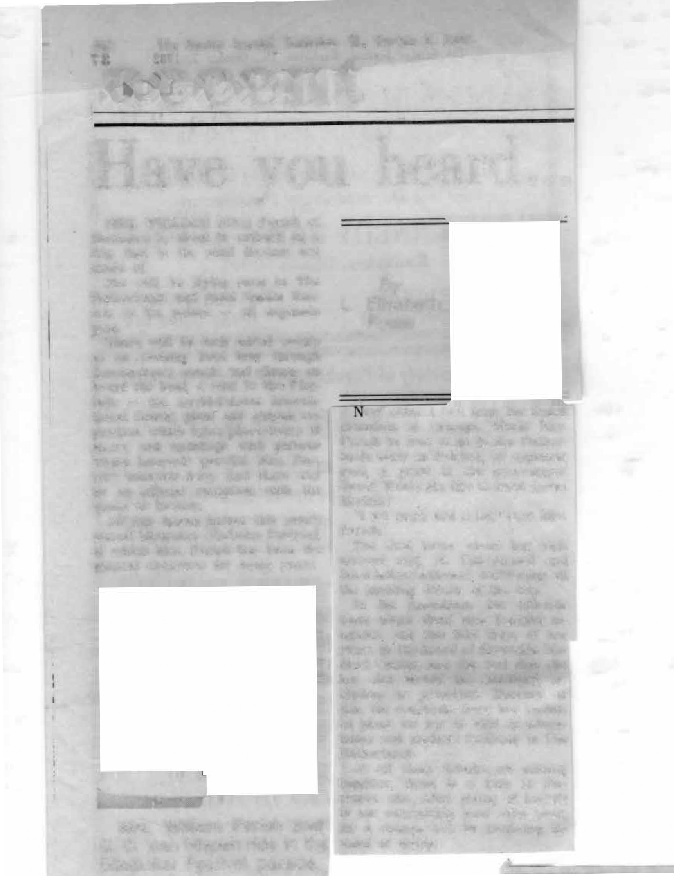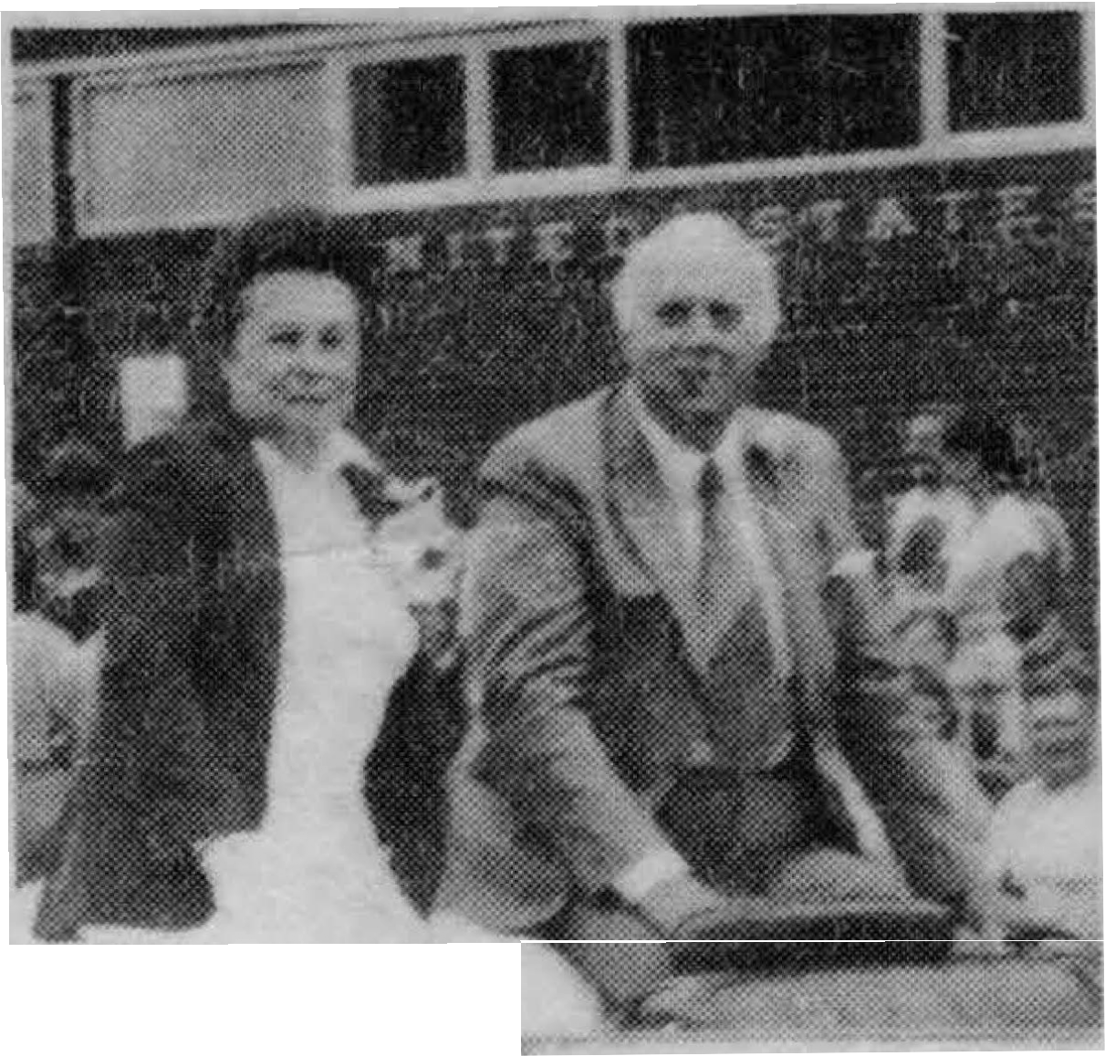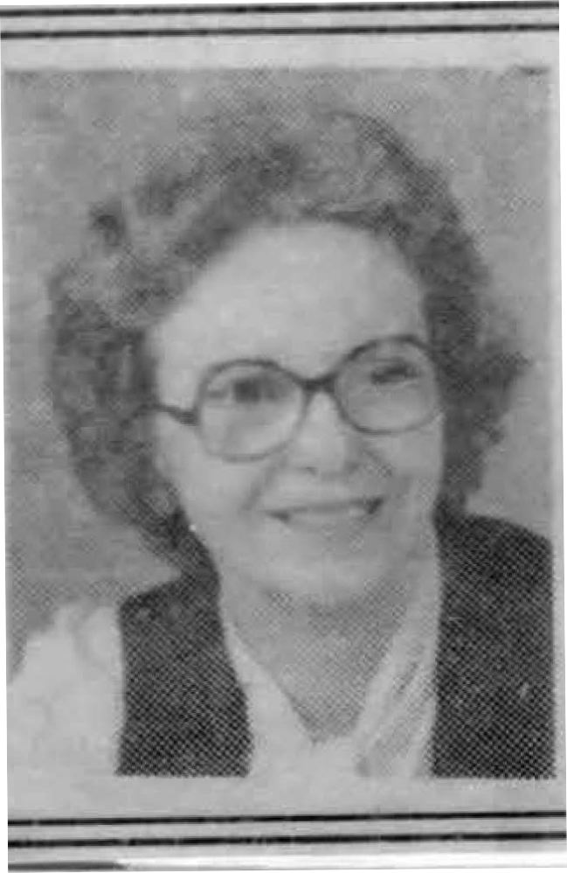Netherlands and meet Queen Bea­ trix at the palace - all expenses paid.
There will be such added events as an evening boat tour through Amsterdam's canals and dinner on board the boat; a visit to the Flor­ iade - the world-famous interna­ tional flower, plant and garden ex­ position, which takes place every 10 years; and meetings with persons whose interests parallel Mrs. Par­ ish's interests here. And there will be an official reception with the queen as hostess.
All this began before this year's annual Momence Gladiolus Festival, of which Mrs. Parish has been the general chairman for many years.

I
Mrs. William Parish and
S. C. Van Nispen ride in the
Gladiolus Festival parade.
L. Elisabeth Fosse

ext came a call from the Dutch consulate in Chicago. Would Mrs. Parish be free to go to the Nether­ lands early in October, all expenses paid, a guest of the government there? Would she like to meet Queen Beatrix?
"I sat down and cried," says Mrs. Parish.
The first letter about her visit arrived Aug. 18. The second and third letters followed, confirming all the exciting details of the trip.
In the meantime, the officials there asked about Mrs. Parish's in­ terests, and she told them of her years on the board of Riverside Me­ dical Center, and the fact that she has also served the auxiliary, in­ cluding as president. Because of this, the consulate there has includ­ ed plans for her to visit to educa­ tional and medical facilities in The Netherlands.
As all these details are coming together, there is a lady in Mo­ mence who, after giving of herself to her community year after year, for a change will be receiving in­ stead of giving.

Mrs. Parish was instrumental in getting a decorated plate through Rep . George O'Brien of Joliet , from the House of Representatives, and a plaque from Momence Chamber of Commerce. to present to the go­ vernment of The Netherlands in commemoration this year of 200 years of unbroken diplomatic and trade relations between The Ne ther ­ lands and the United States. It was also the 45th year for the glad fest i­ val.
After the gift were received by The Netherlands, gifts were sent back to Momence , including a book on Dutch American history that was presented to the Momence Histori­ cal Society. The Dutch bicentennial flag was sent to the Momence Band. It was carried in the glad festival parade, and will be carried in future parades. Also given were books for every student in grades 4 through 12 in Momence schools.
Then, when Rodger Vandervliet, former Wichert artist, brought the art display from the Royal Aca­ demy of Fine Art in the Hague , Netherlands to Kankakee, the consul general - S. C. Van Nispen - came here . Mrs. Parish arranged for him to be guest of honor at the festival. He was in the Saturday parade , went to the flower show and the drum and bugle corps show. He was also a guest in Mrs. Parish 's home.

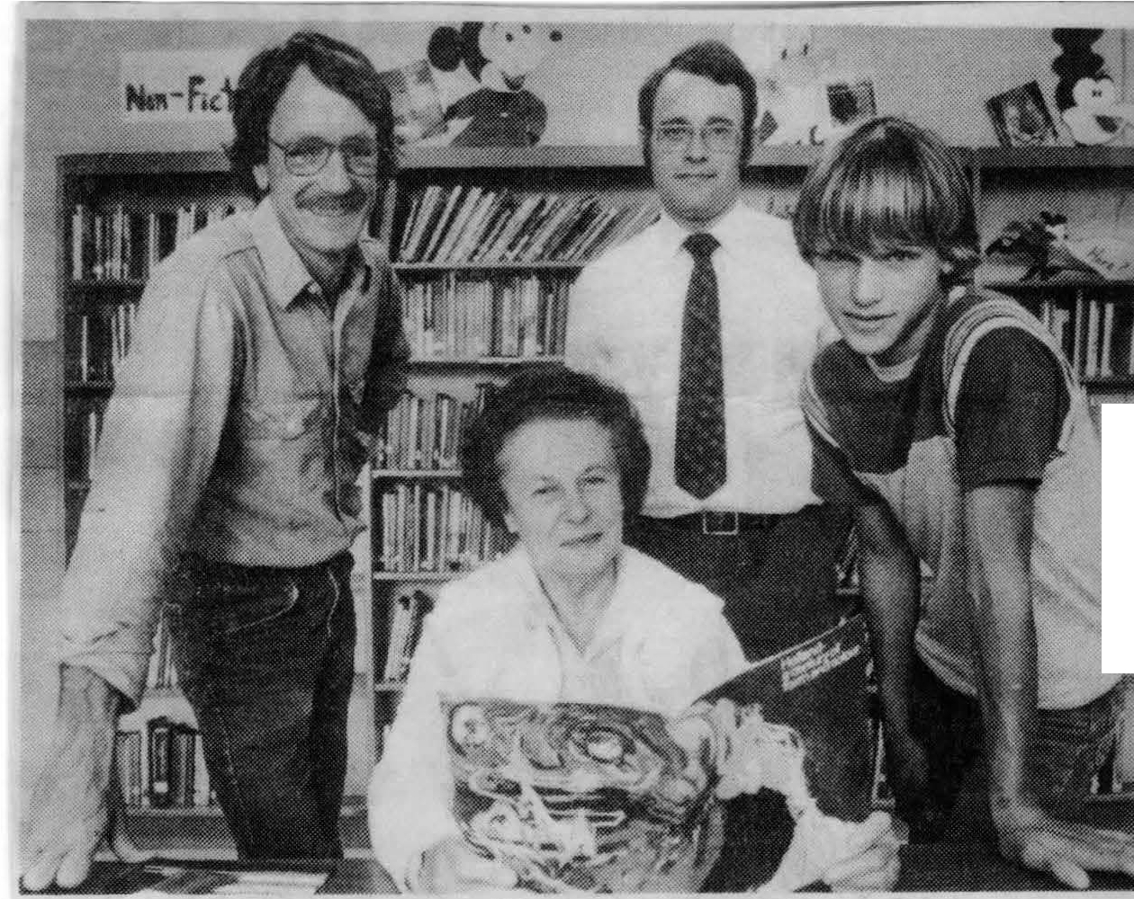Gifts from The Netherlands
i
There was an exchange of gift between Momence and The etherland afte r Mrs. William Parish, chairman of the Momence Gladiolus Festival for many years, was hostess to S. C. Van Nispen, consul-gener al of The ether lands. Among gifts from The ether­ lands we re books for students in the Momence schools. Looking at the book from le ft, standing, are Paul Bradley, president of the Momence chool Board; Kenneth Fox, principal of Momence Junior High, and Randy Halihan , an eighth grader. Mrs. Parish is
ea ted.

